.NET Framework Class Library
.NET Framework Class Library is the collection of classes, namespaces, interfaces and value types that are used for .NET applications.
It contains thousands of classes that supports the following functions.
- Base and user-defined data types
- Support for exceptions handling
- input/output and stream operations
- Communications with the underlying system
- Access to data
- Ability to create Windows-based GUI applications
- Ability to create web-client and server applications
- Support for creating web services

.NET Framework Class Library Namespaces
Following are the commonly used namespaces that contains useful classes and interfaces and defined in Framework Class Library.
Namespaces | Description
System | It includes all common datatypes, string values, arrays and methods for data conversion.
System.Data, System.Data.Common, System.Data.OleDb, System.Data.SqlClient, System.Data.SqlTypes | These are used to access a database, perform commands on a database and retrieve database.
System.IO, System.DirectoryServices, System.IO.IsolatedStorage | These are used to access, read and write files.
System.Diagnostics | It is used to debug and trace the execution of an application.
System.Net, System.Net.Sockets | These are used to communicate over the Internet when creating peer-to-peer applications.
System.Windows.Forms, System.Windows.Forms.Design | These namespaces are used to create Windows-based applications using Windows user interface components.
System.Web, System.WebCaching, System.Web.UI, System.Web.UI.Design, System.Web.UI.WebControls, System.Web.UI.HtmlControls, System.Web.Configuration, System.Web.Hosting, System.Web.Mail, System.Web.SessionState | These are used to create ASP. NET Web applications that run over the web.
System.Web.Services, System.Web.Services.Description, System.Web.Services.Configuration, System.Web.Services.Discovery, System.Web.Services.Protocols | These are used to create XML Web services and components that can be published over the web.
System.Security, System.Security.Permissions, System.Security.Policy, System.WebSecurity, System.Security.Cryptography | These are used for authentication, authorization, and encryption purpose.
System.Xml, System.Xml.Schema, System.Xml.Serialization, System.Xml.XPath, System.Xml.Xsl | These namespaces are used to create and access XML files.

.NET Framework Base Class Library
.NET Base Class Library is the sub part of the Framework that provides library support to Common Language Runtime to work properly. It includes the System namespace and core types of the .NET framework.
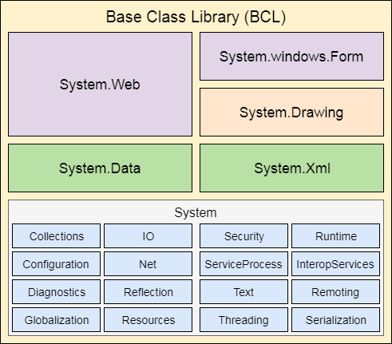
Next Topic

